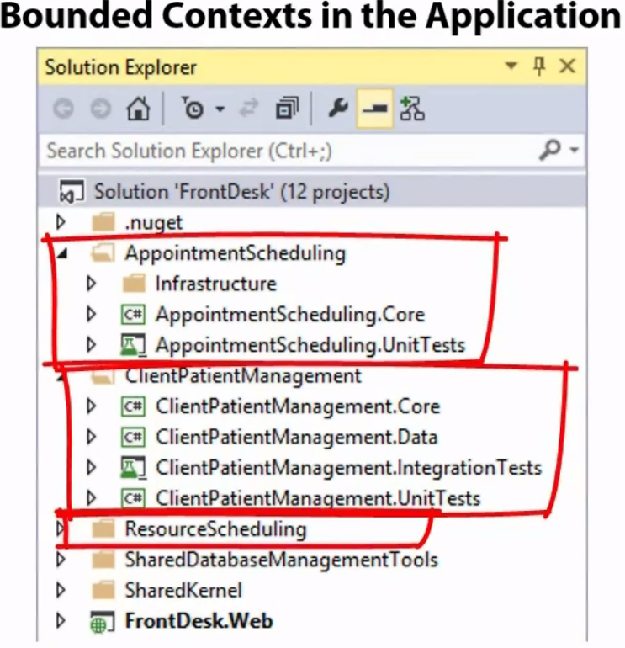

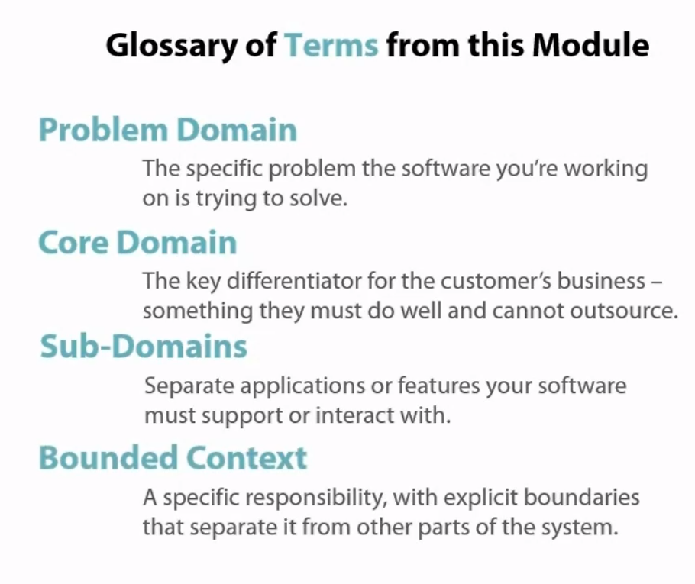

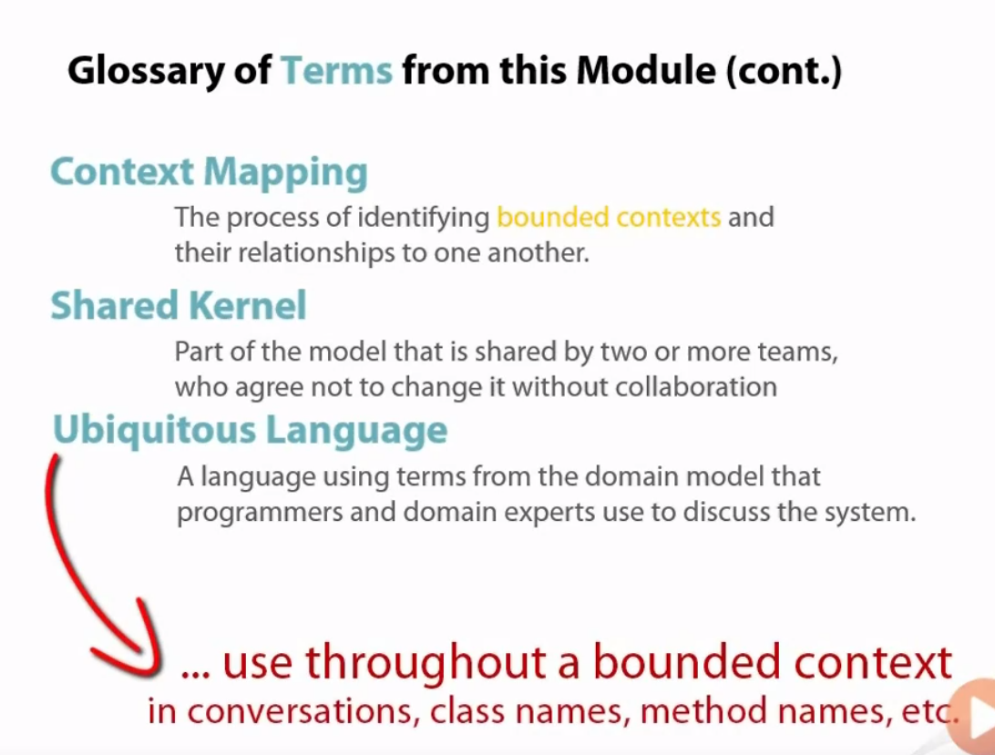

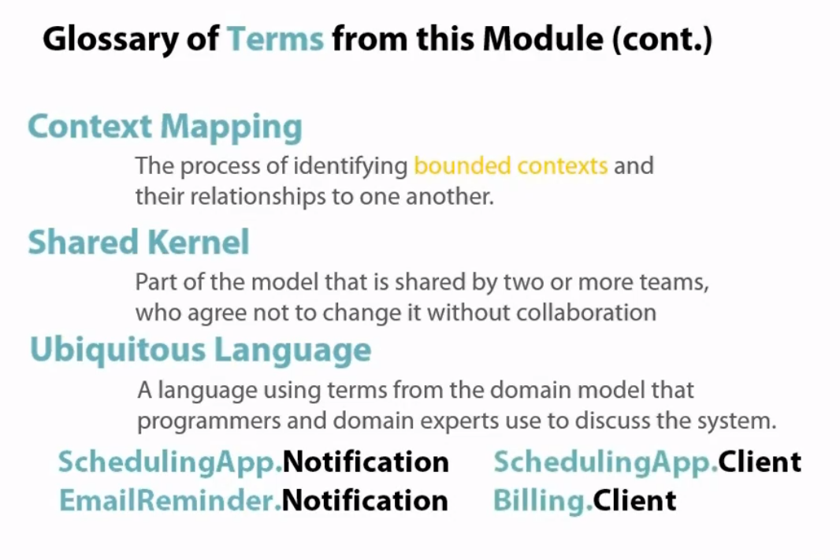

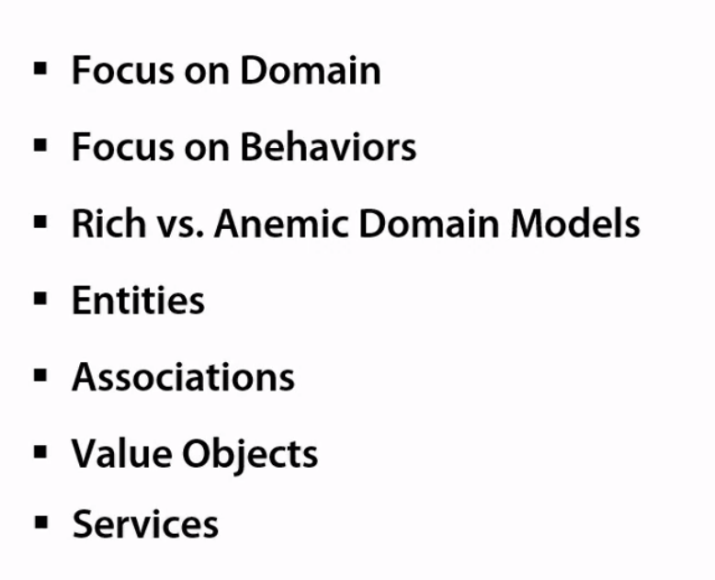

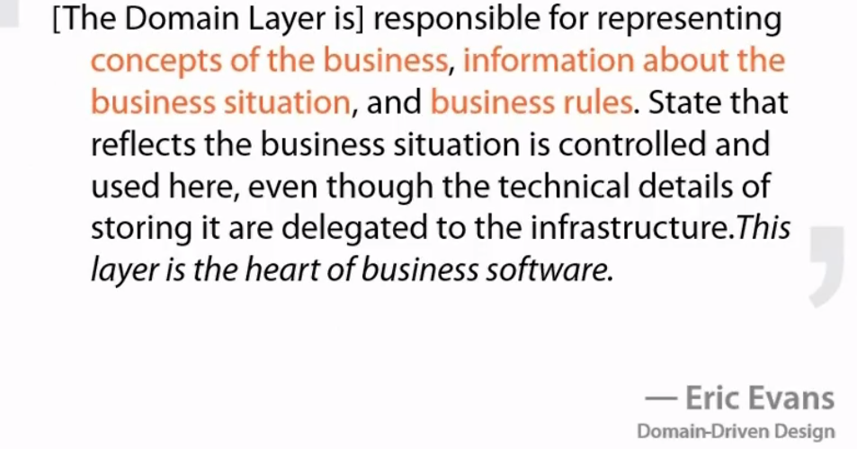

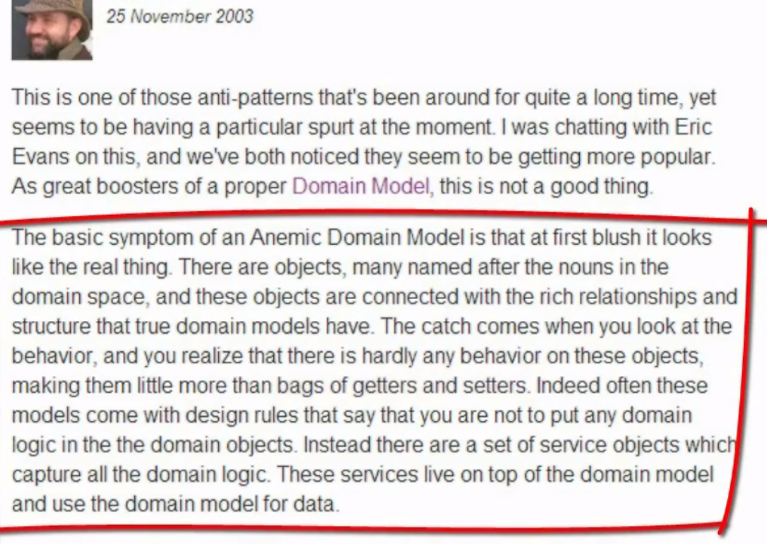

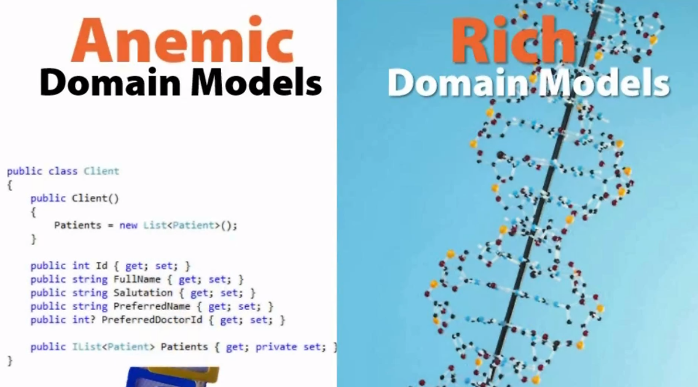

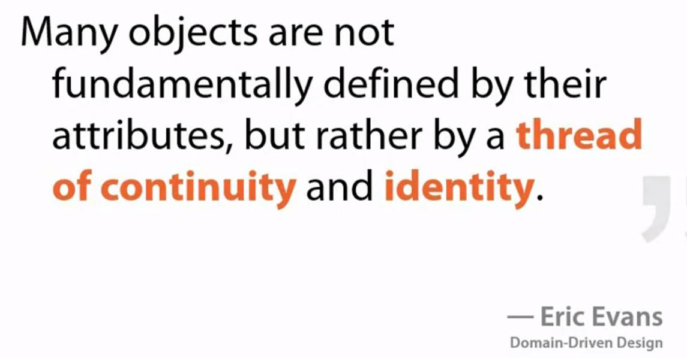

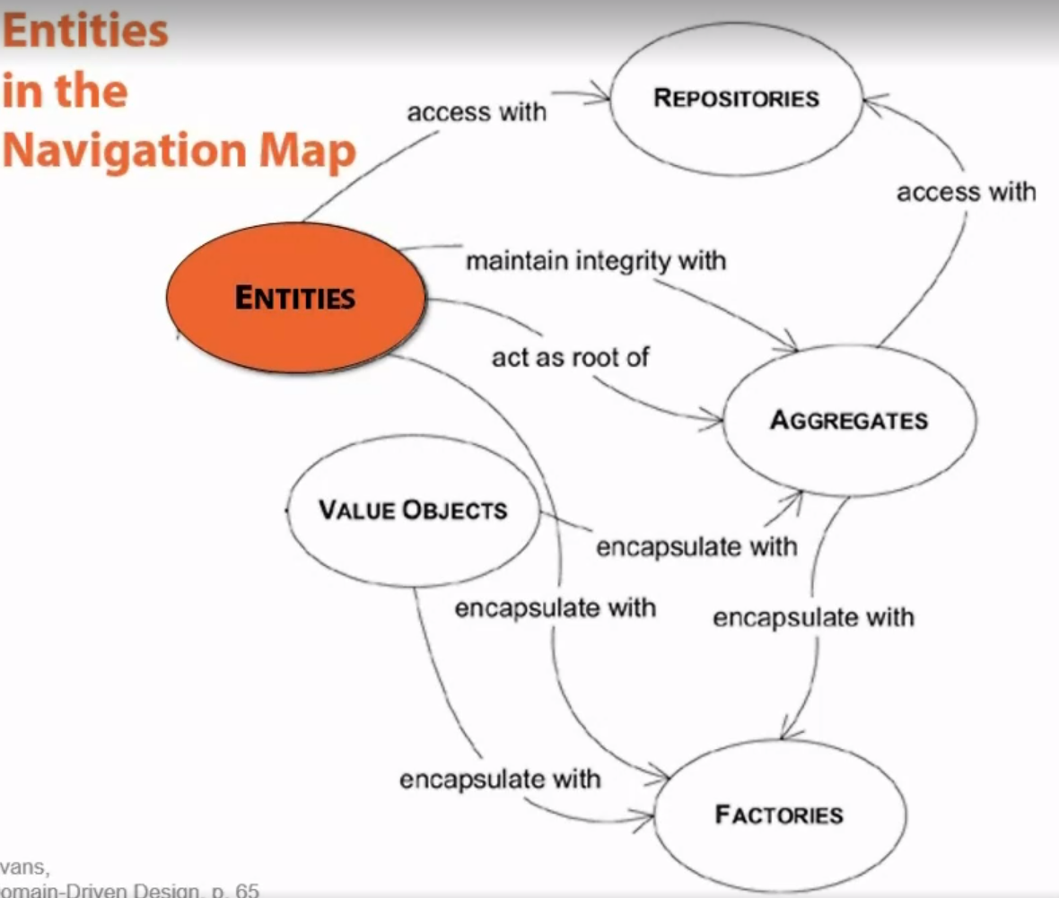

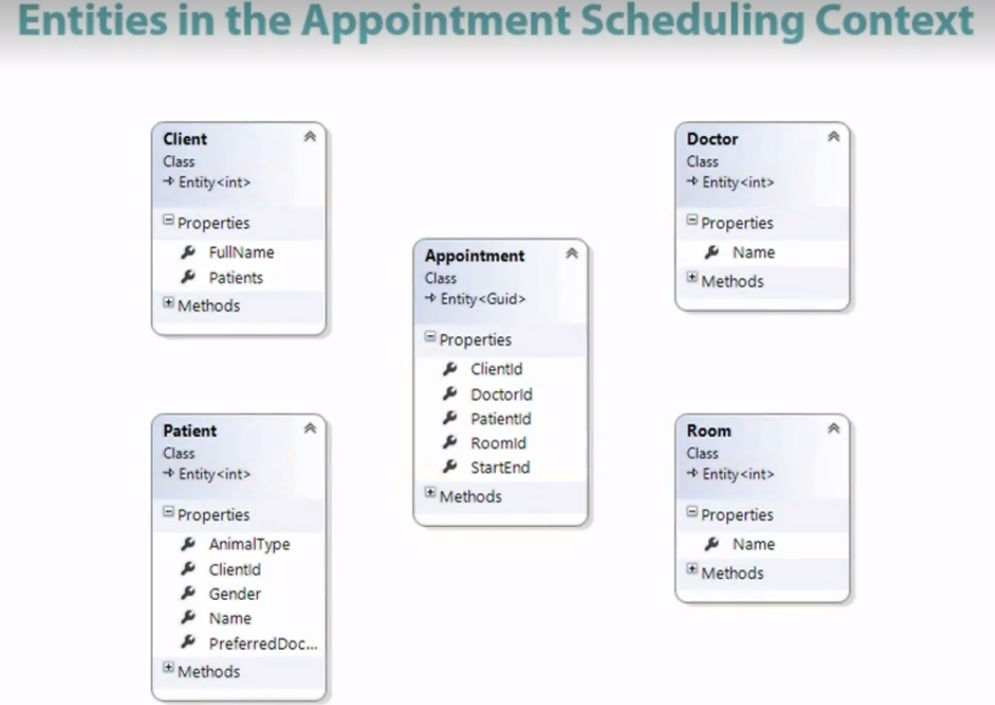

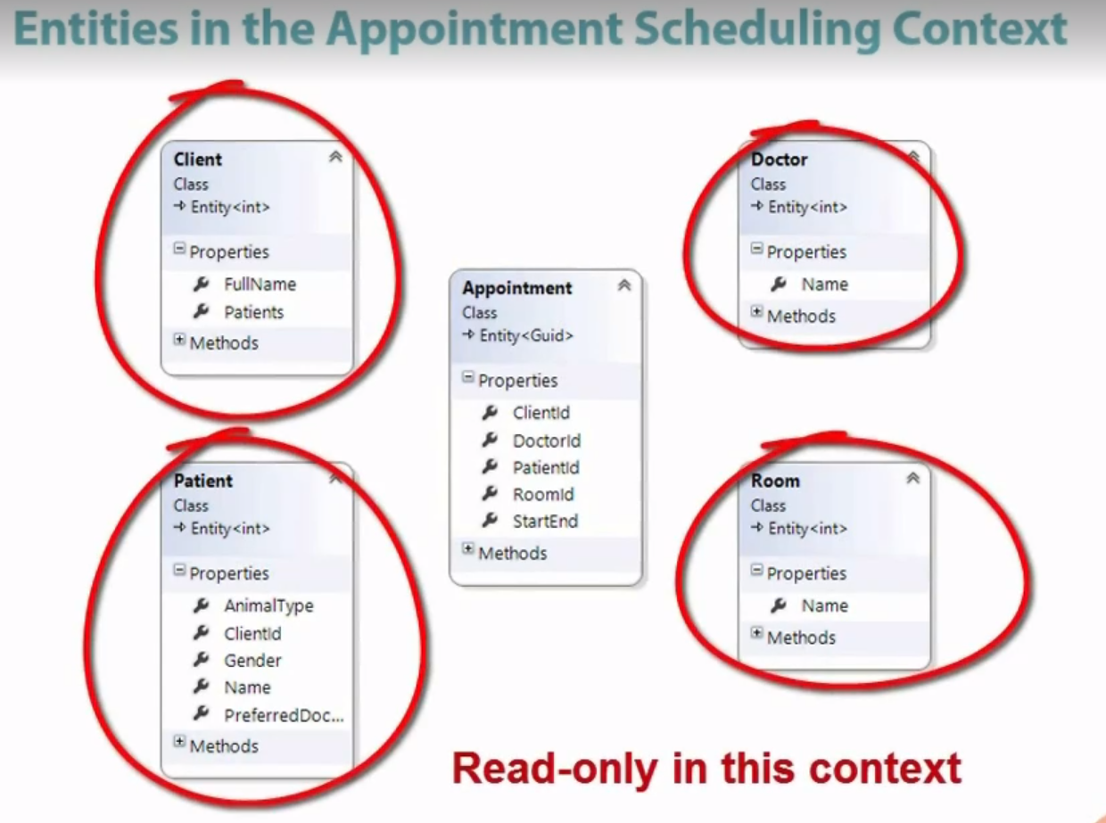

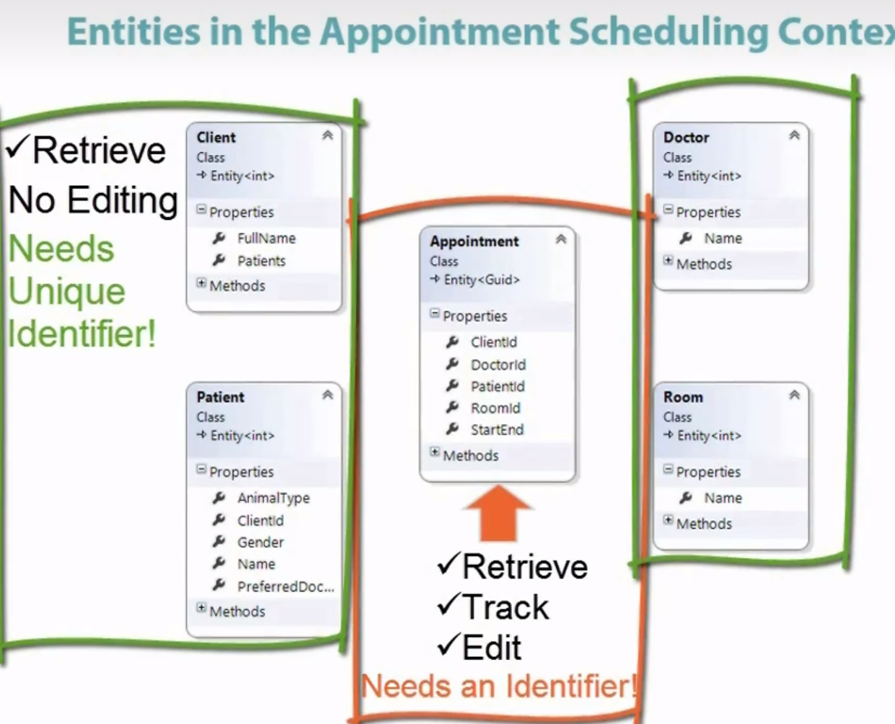

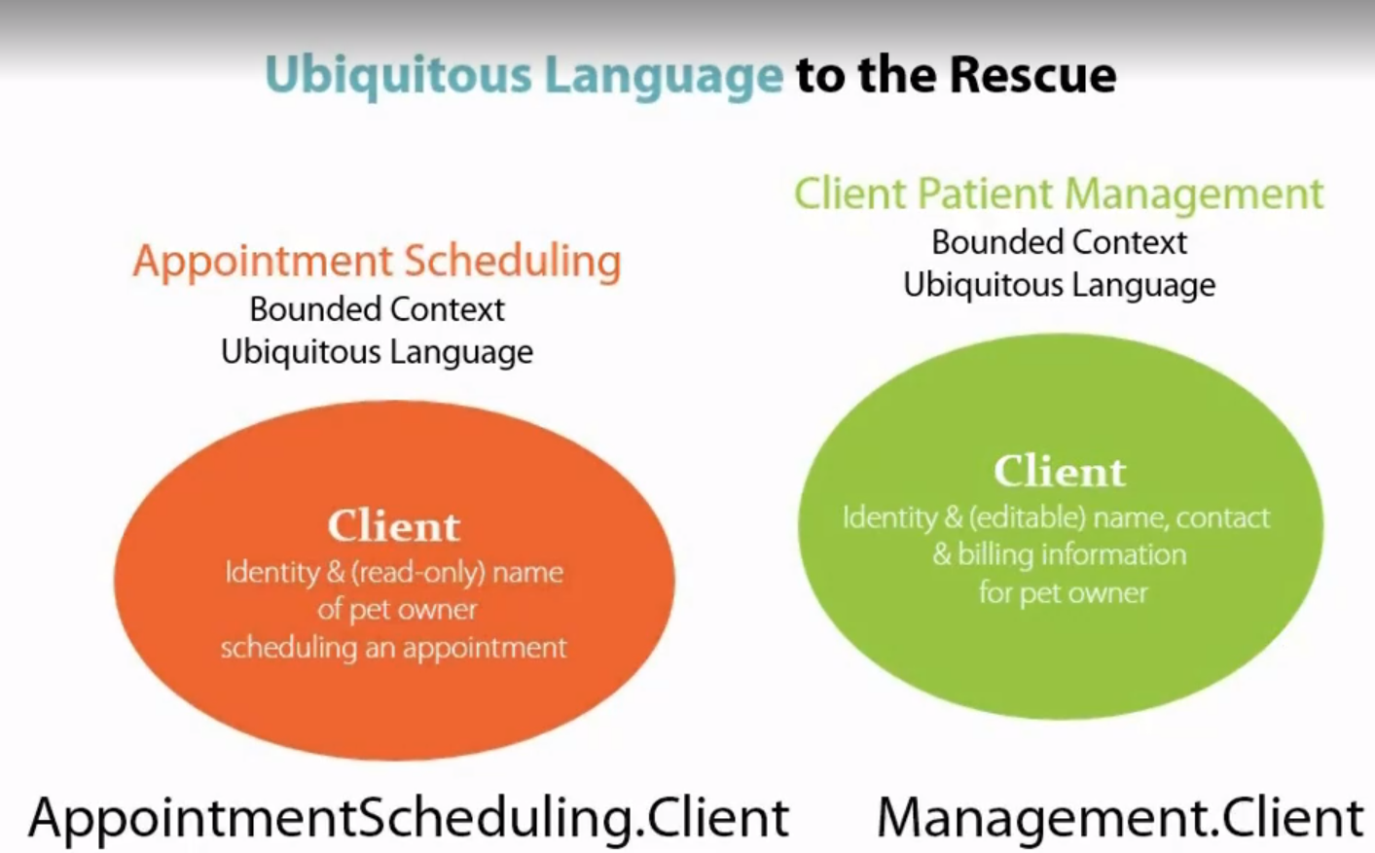

Appointment class with some behavior handled in that. We want a rich model which are just not getter and setter but also behavior handled.

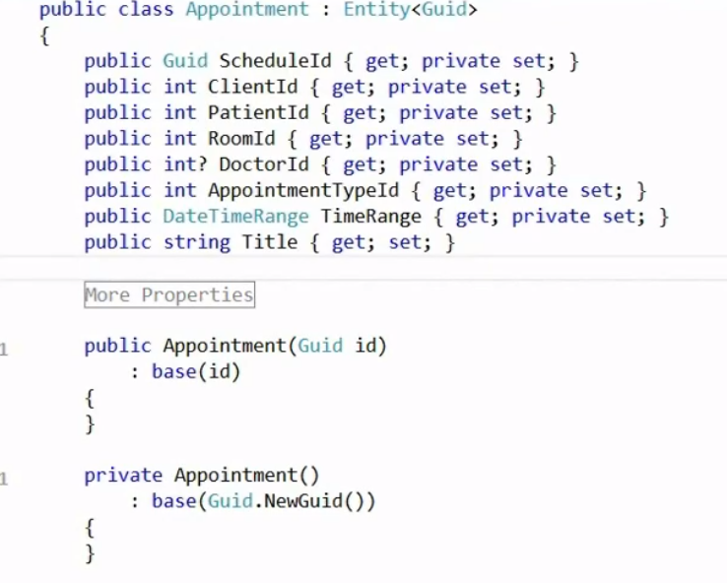

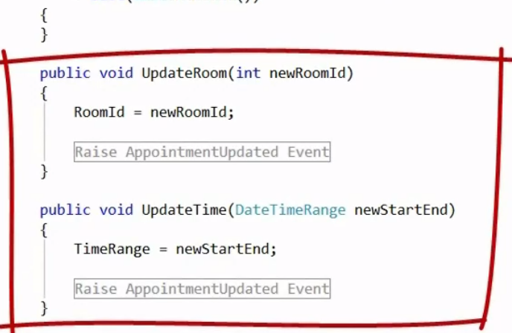

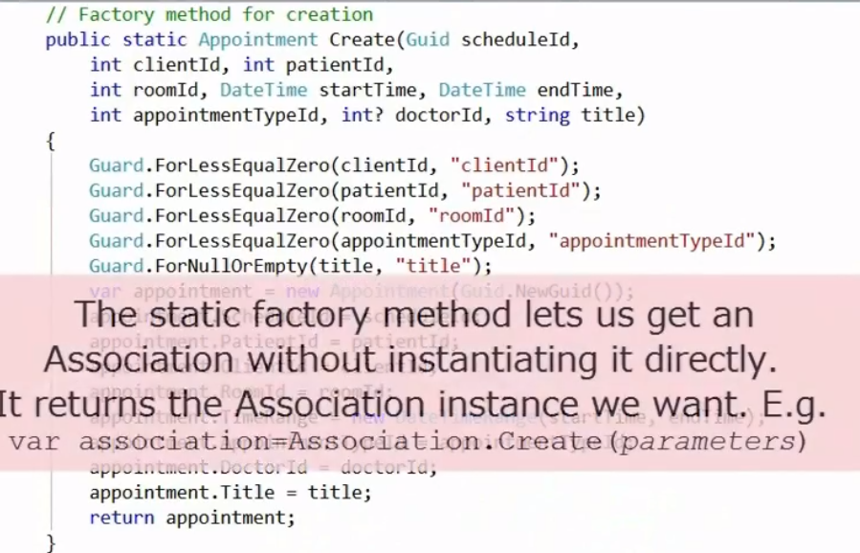

Basic static factory method to do some valid basic checks. Through this we can avoid partial filled up entity which is inconsistent.

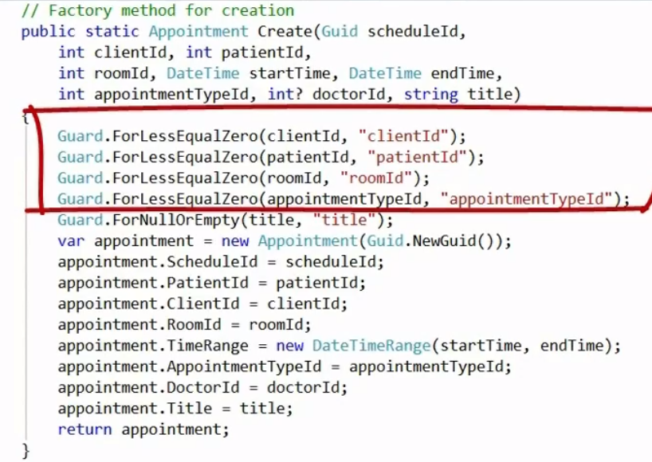

Below doctor have id type integer because in this it is read only we not creating any new doctor from this binded context that is appointment. Will have doctor id as GUId in binded context of doctor (or resoucres)

Benefit of using GUID and not integer is. It gets genertaed in the code itseld we don’t have to wait from database to return the unique id and then create the thing. We can create on fly.

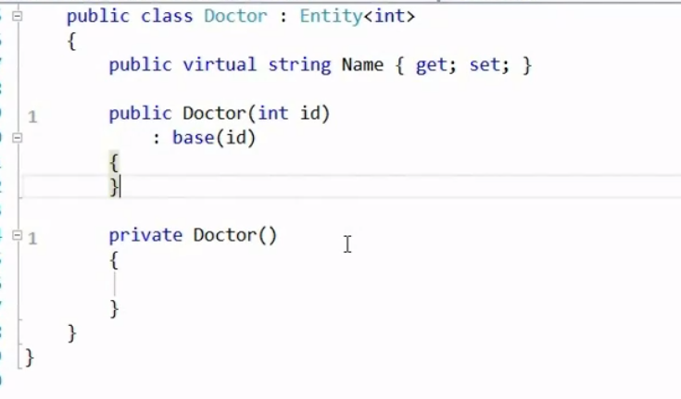

You should try to unidirectional relational. Bidirectional relationships are quite confusing.

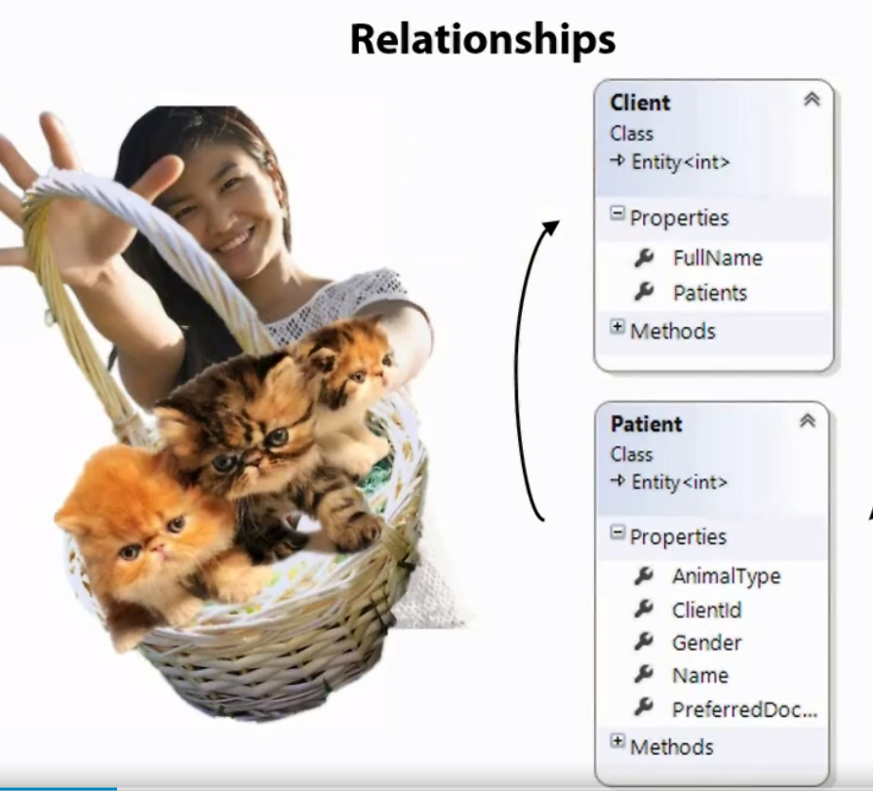

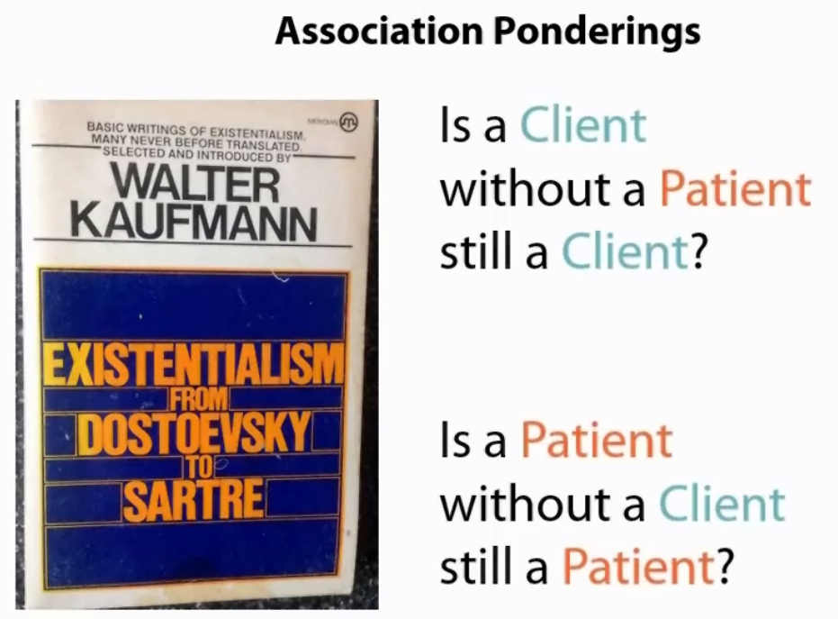

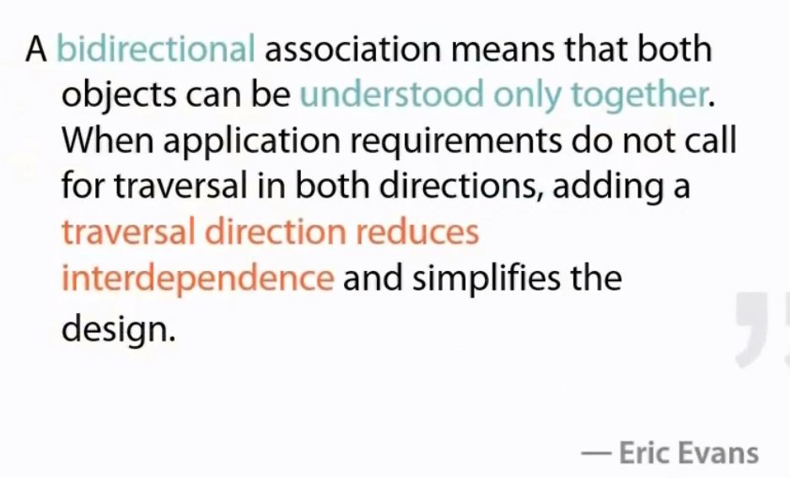

Here we are talking about appointment bounded context, so for an appointment we need a patient, for a client to book and appointment patient should be there.

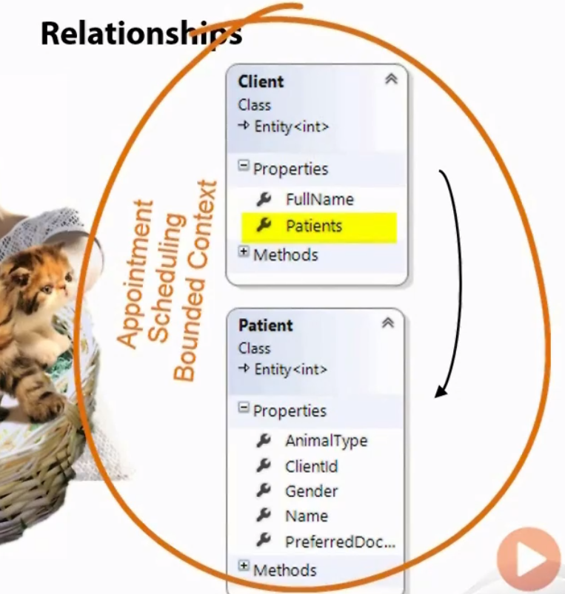

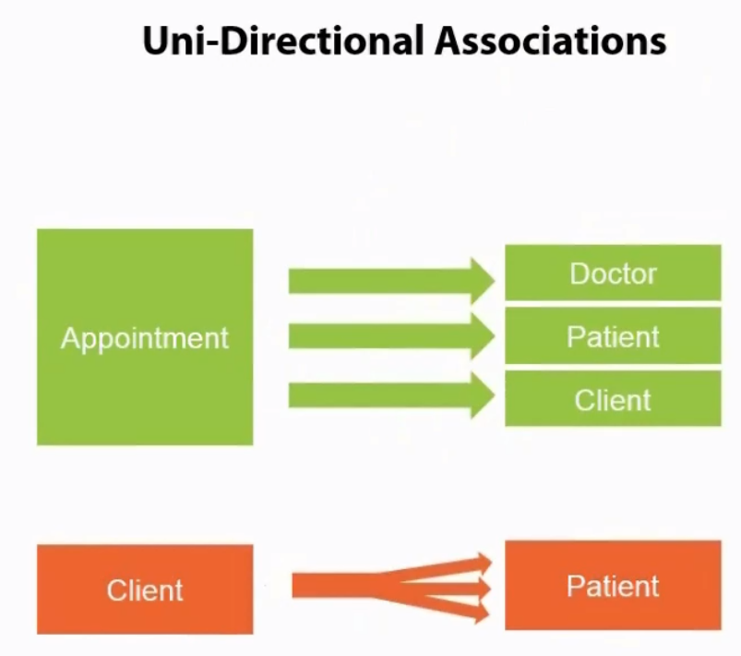

We need Doctor , patient and client to book the appointment but we don’t need appointment for doctor to exist. So in appointment context this way it is uni directional

Also, we need a client to book appointment t for a patient.. patient cannot book appointment on this own. It is an animal here.

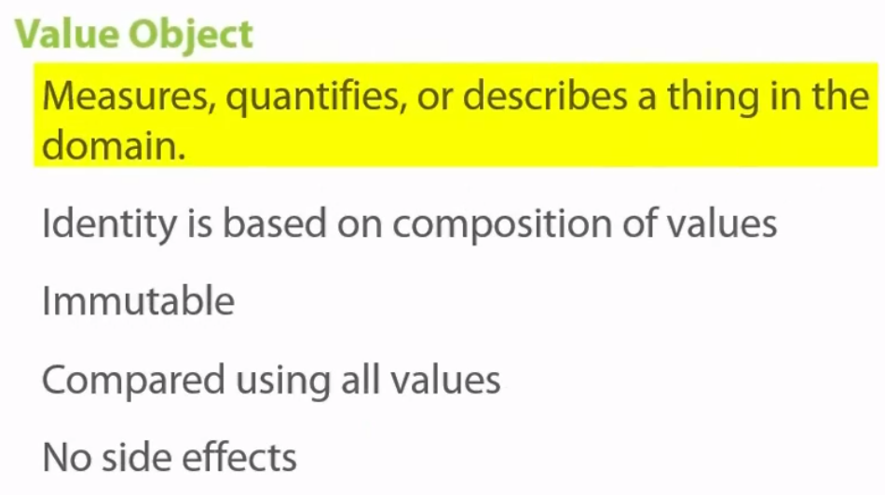

Here we are talking about other properties in the context. Which can be string. As you know string is immutable, when you update any string it always create copy of the string and update that and return. This how string works in .net

Here they are trying to explain that how putting different string together as a different property create a value object.

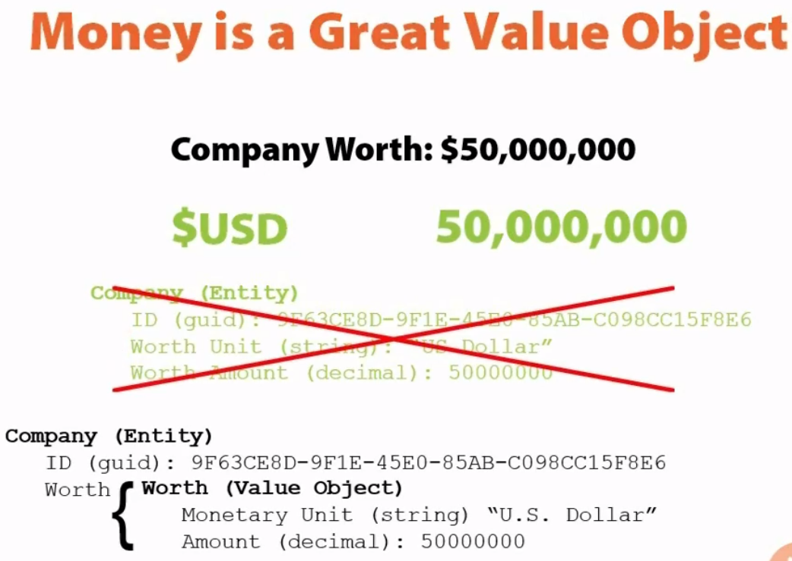

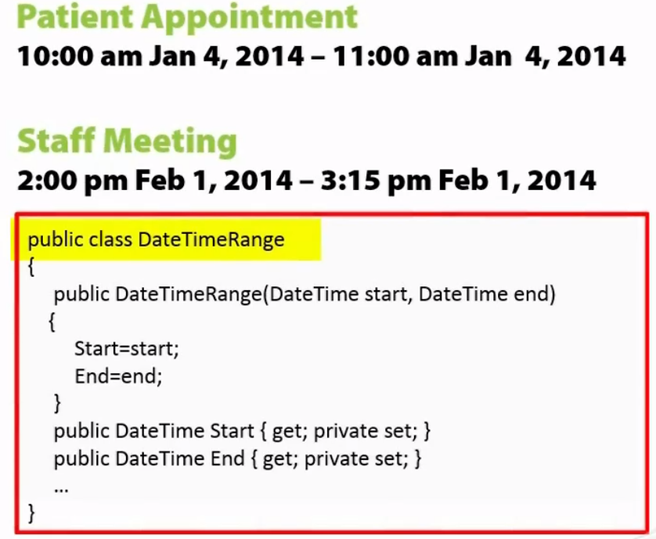

This is how you can make setter immutable(nobody can change it). It is private hence cannot be updated.

You can read the time from this.

Here dateTimeRange is a value object.

By Eric Evans:

Value object are a really good place to put methods and logic, a better place than entities.

Value object is object with some logic around it and has no side effects as they are immutable. We should try to create as much as value objects we can. Think first before can this became a value object? And they start.

See “value object in our code” session for help in code in Domain Drive Design fundamental course Plural sight.

See this class DateTime, doing so many job and logic, more than be a getter and setter.

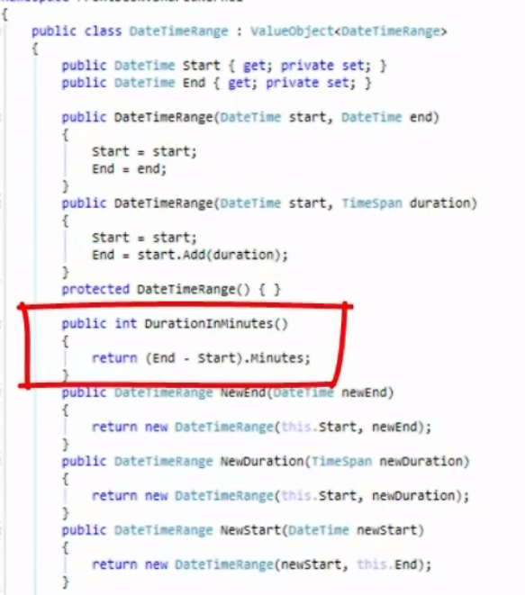

This is simple value object.

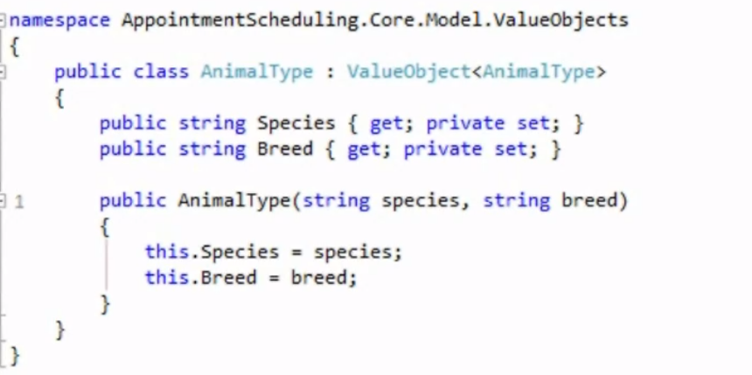

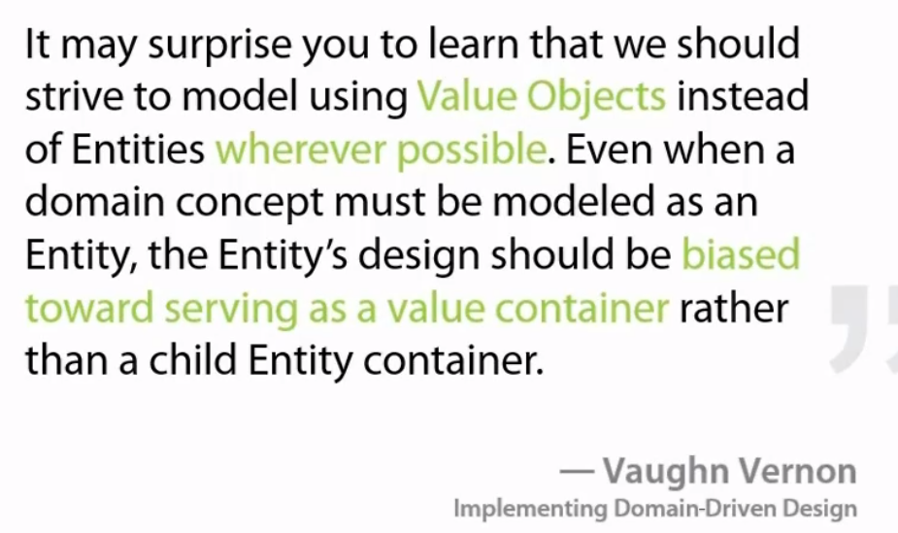

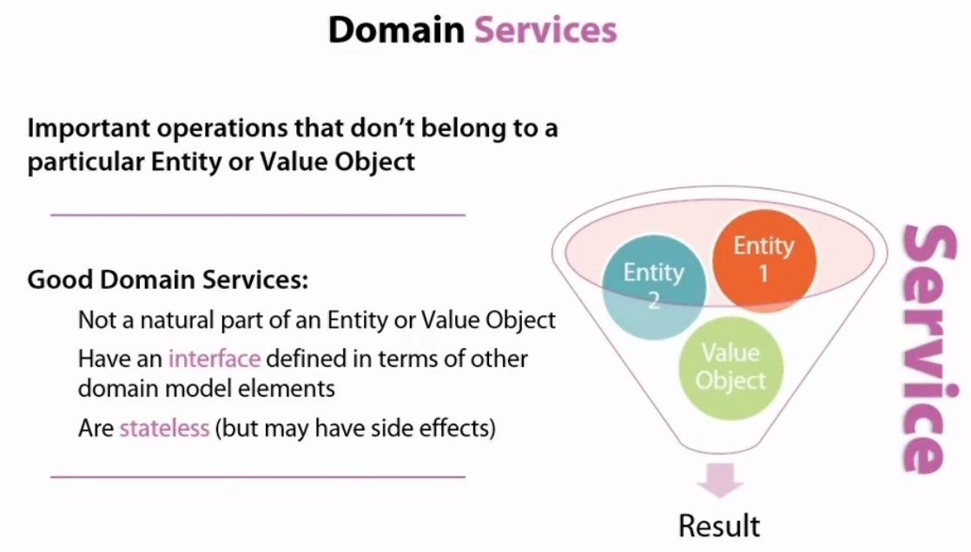

This is how you can define the structure of the project.

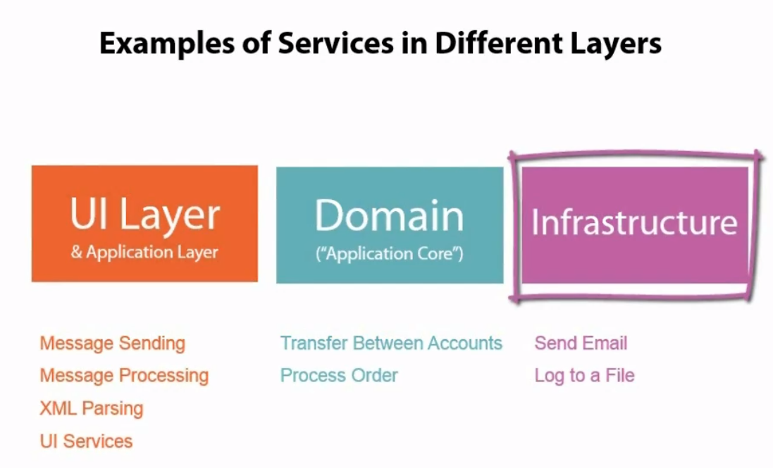

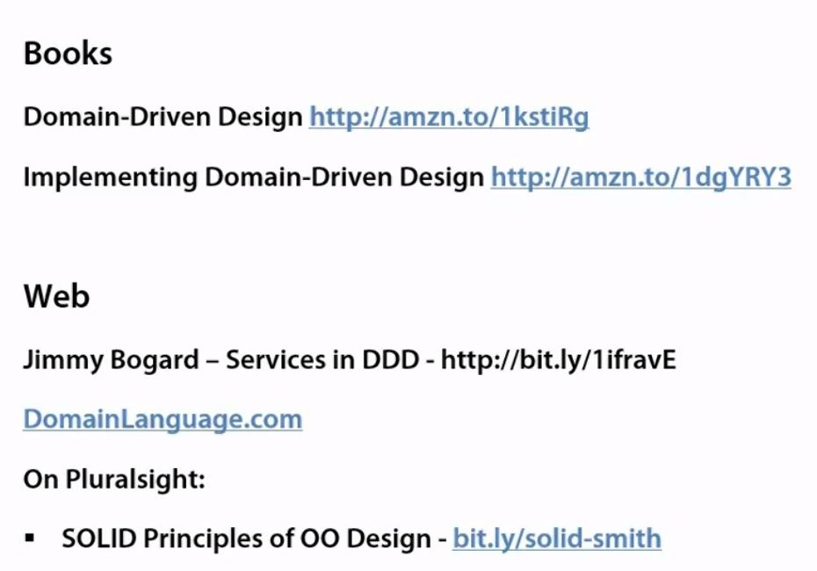

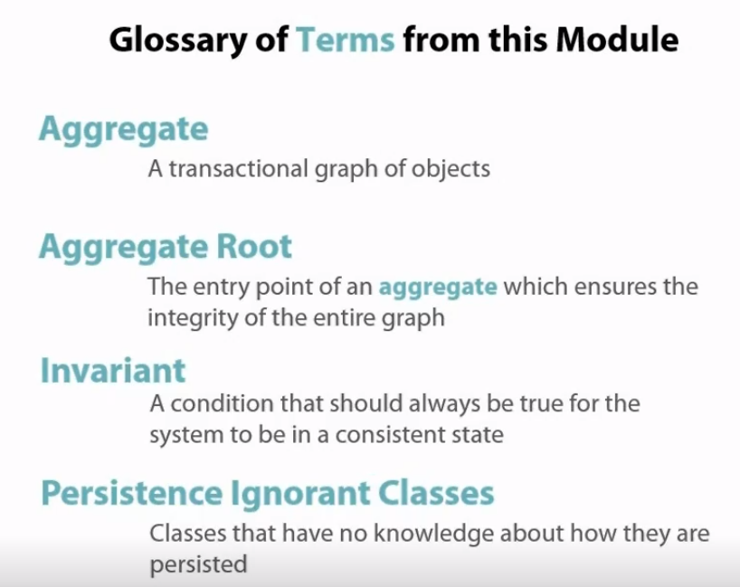

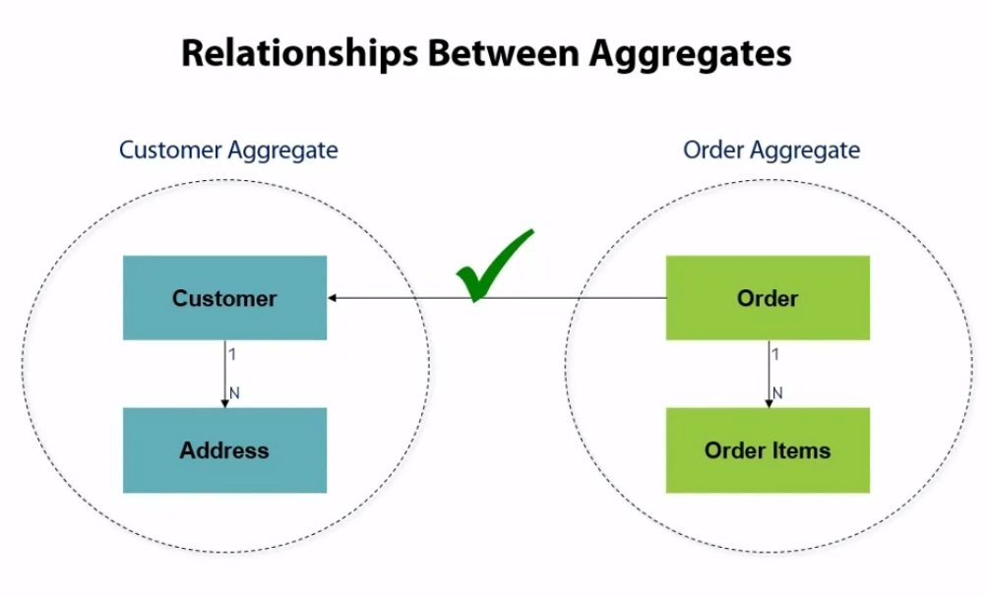

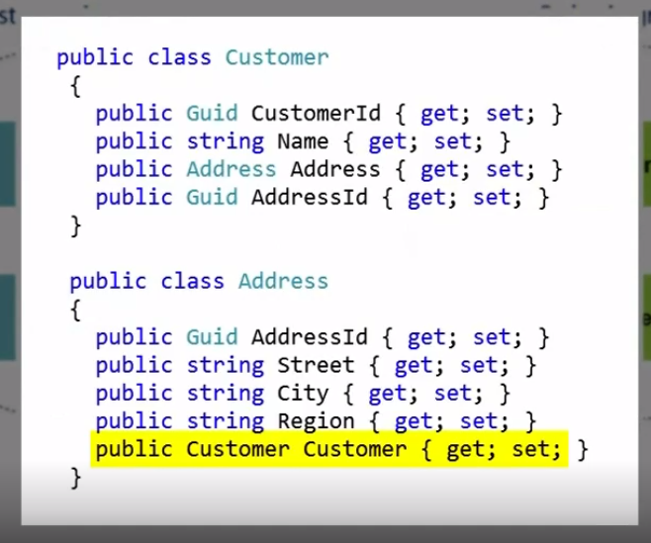

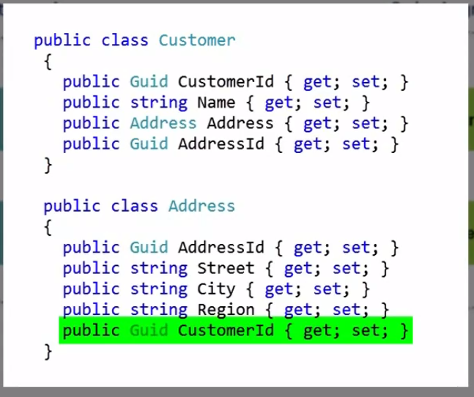

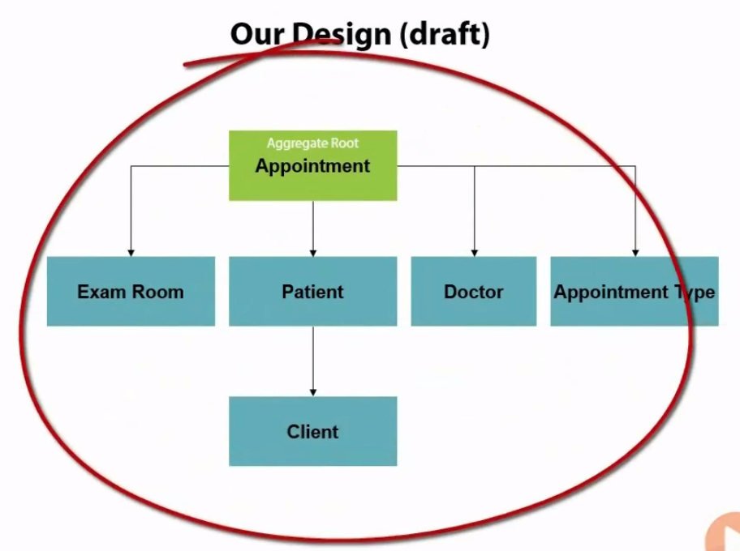

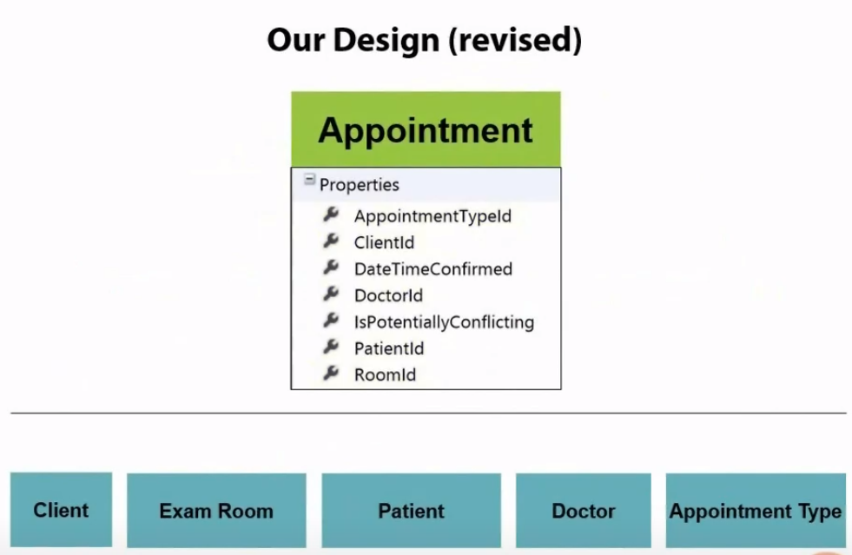

Invariants

Something that needs to be as specified for system to be stable and consistent

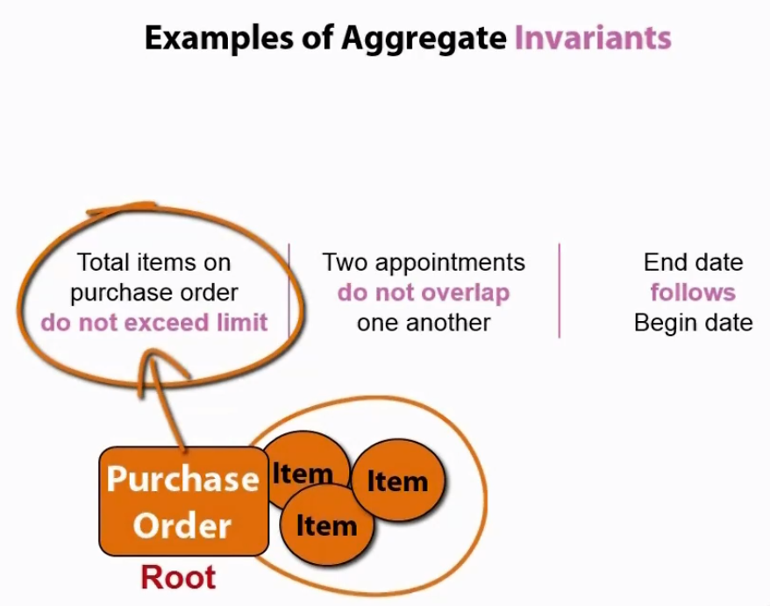

Appointment does not know any thing about the other appointment but schedule does know.

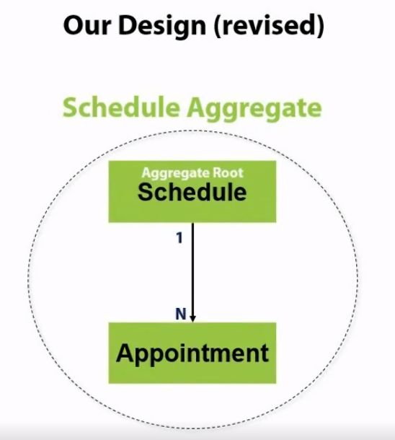

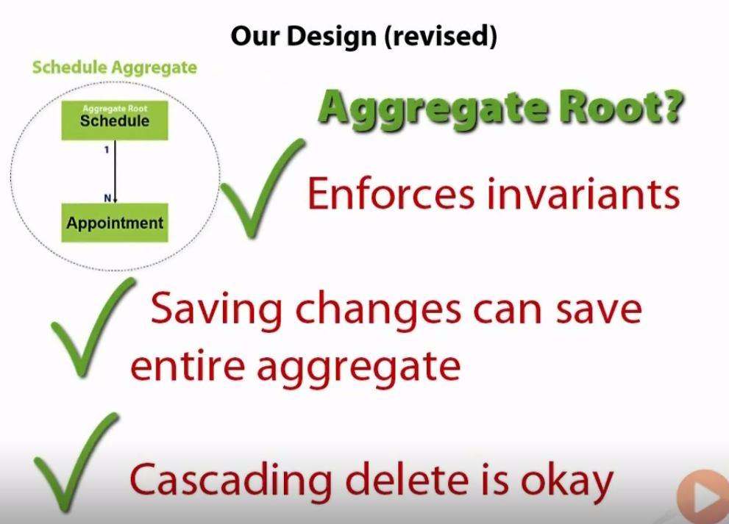

Pratical application of this can be seen in The schedule aggregate in Ou…. In DDD fundamental plural sight.

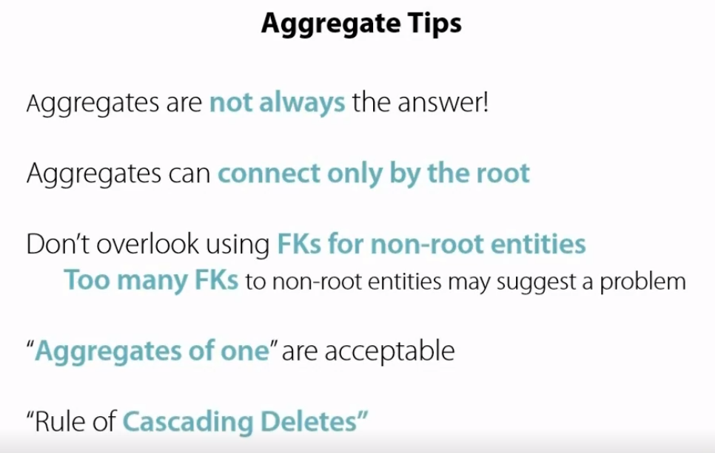

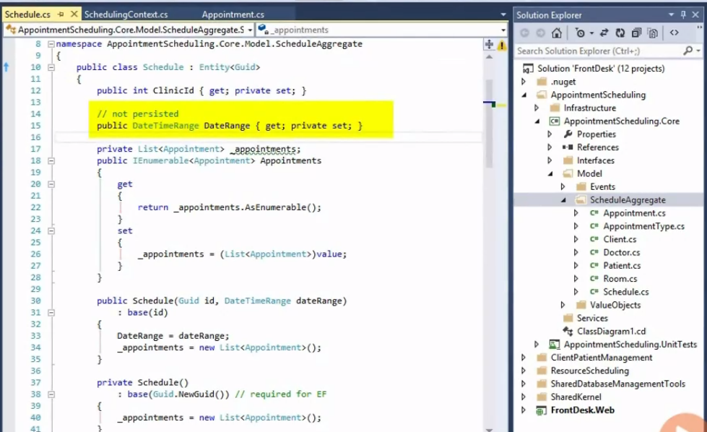

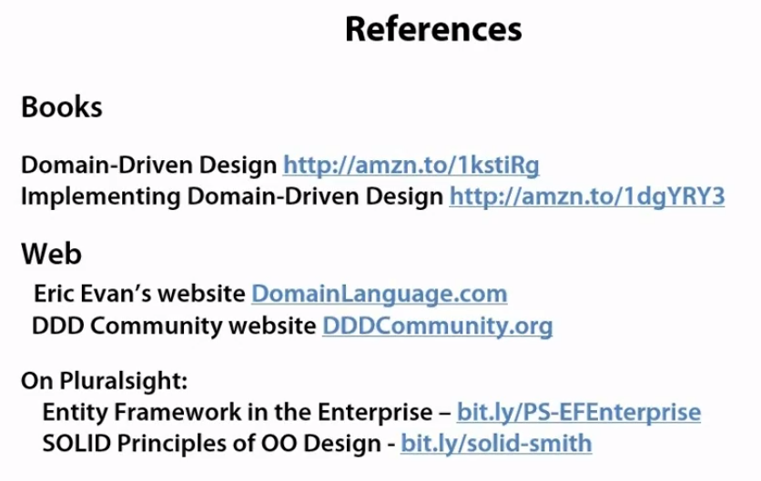

Repository

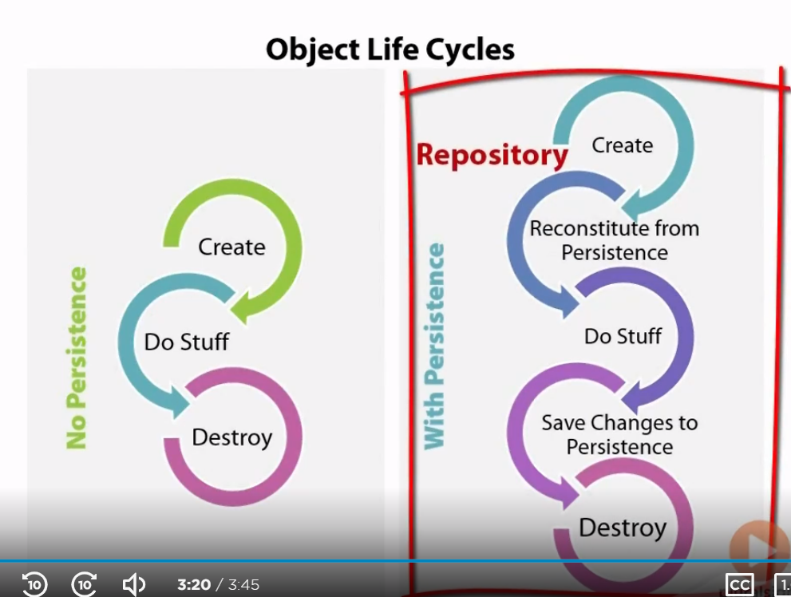

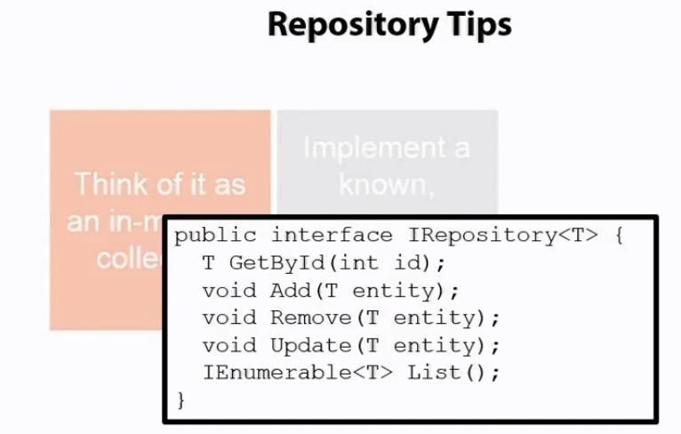

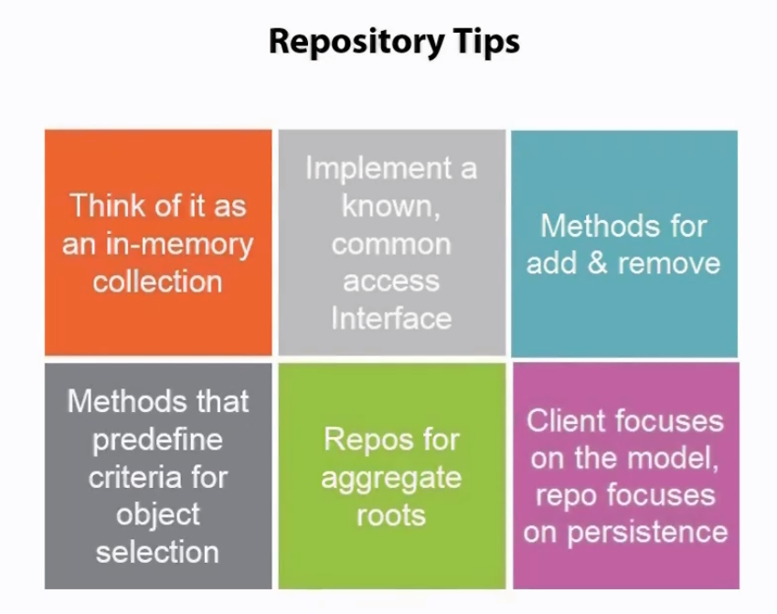

Domain events are complete class which we raised as an when needs.

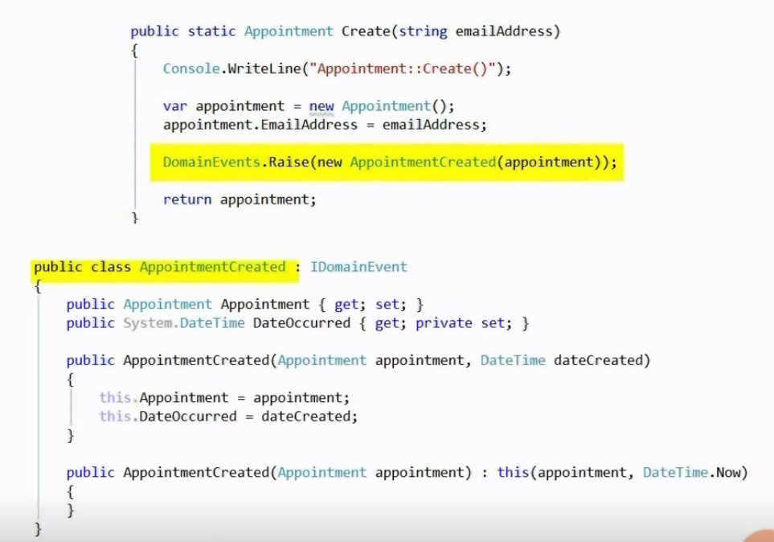Like here AppointmentCreated is an domain event.

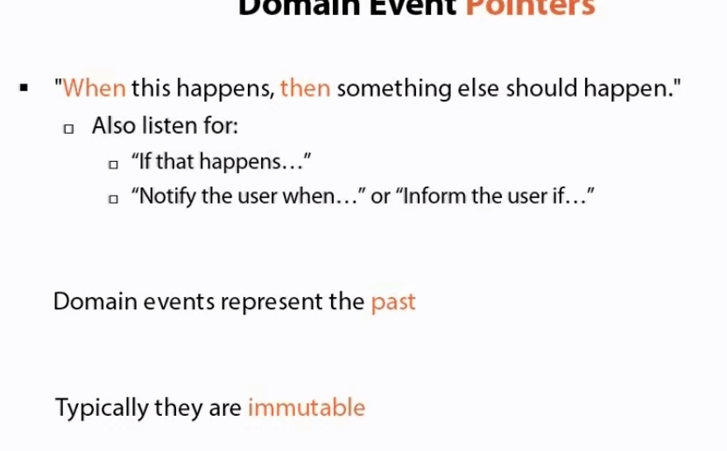

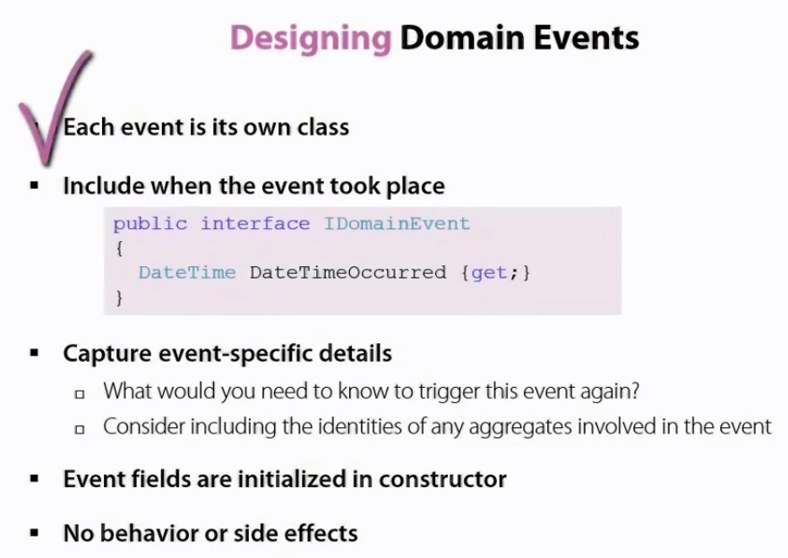

Base code is available online. We don’t really need to structure of basic event raise logic. Udi Dahan’s code you can check. Link is below.

Check “Domain events in simple console application and Domain events in our Application.

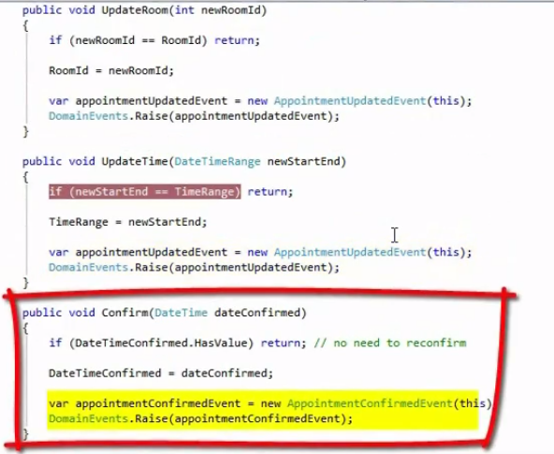

Domain Events is achieved by IoC, inversion of control (dependency injection)

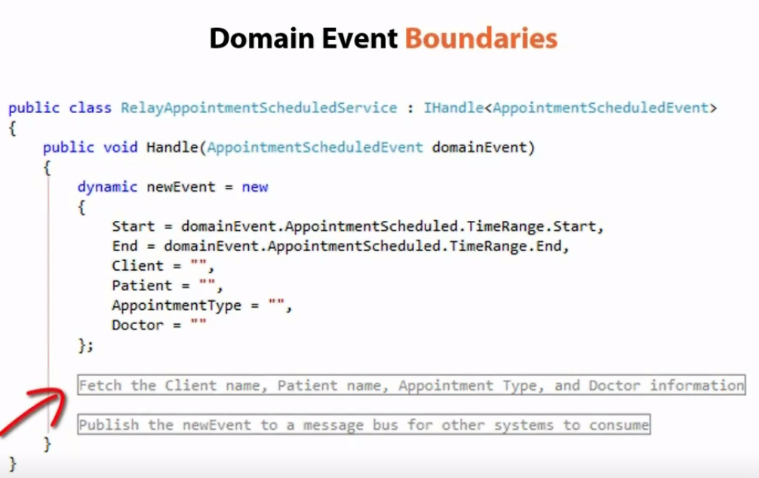

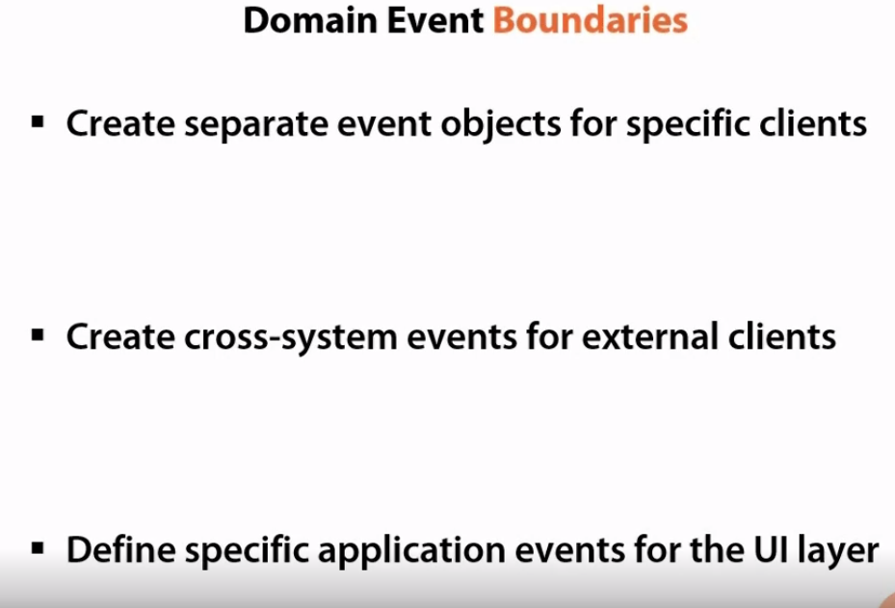

Anti corruption layer

